**LAB # 8**

**COLLABORATIVE FILTERING**

**OBJECTIVE**

Implementing collaborative filtering for a recommender system.

**Lab Tasks:**

For the given dataset, build a recommender system using item based collaborative filtering, which recommends movies for a selected user. If we enter a user name into the recommender, the recommender is supposed to return the list of recommended movies which have the highest predicted ratings. Use Nearest Neighbors to calculate the distance between movies by using the cosine similarity.

* **CODE:**

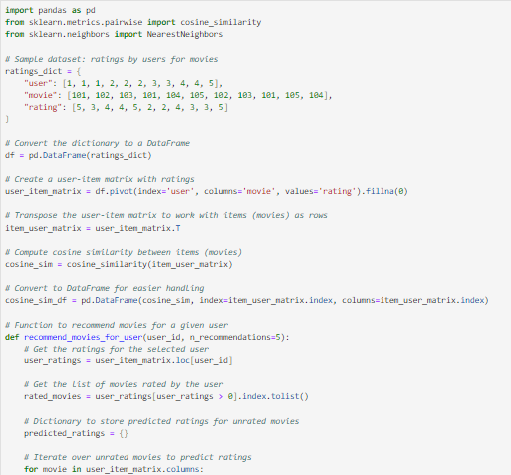

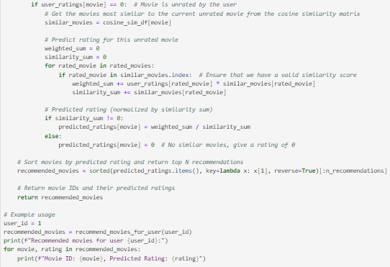

* **OUTPUT:**

**Home Task:**

* 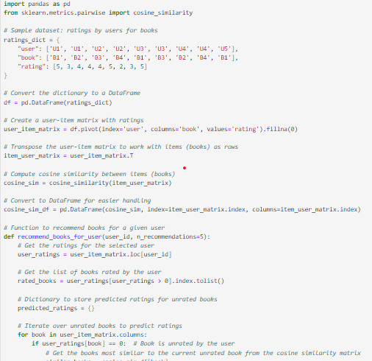**CODE:**

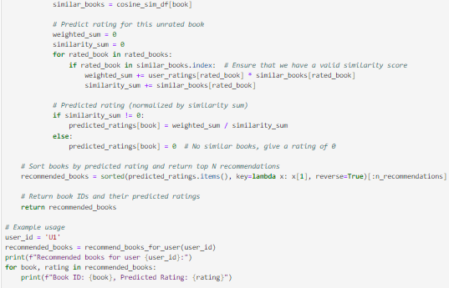

* **OUTPUT:**



* **File Upload On Github:**